Acceptable Authentication Assurance Policy Template
Questions to ask yourself when defining this policy:
- Which identity providers are acceptable for your infrastructure? SAML Identity Federation IdPs? Social providers such as Google, Facebook etc?
- How much certainty does your community require of the identity? Review each of the elements (personal accounts, uniqueness, freshness, vetting quality, and authentication strength). How will you validate this for each source of (federated) identity?
- How can you ensure that each user is covered by a security incident response capability at their home organisation?
- Do your services, or a subset, require step-up (multi-factor) authentication?

The following chart can be used to help determine an appropriate assurance profile for you. Refer also to AARC Guideline 21:
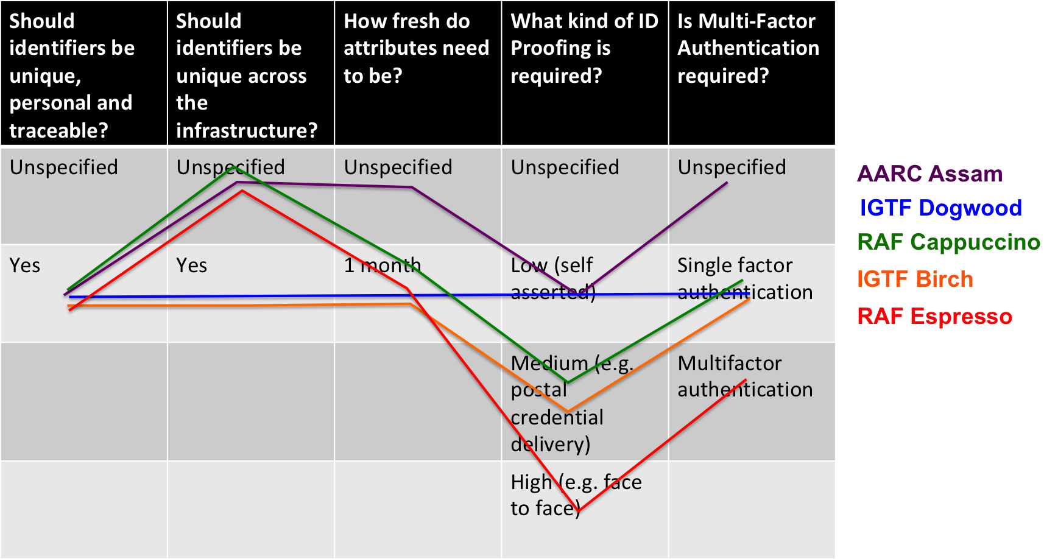

This policy is effective from <insert date>.

INTRODUCTION
In order to protect its assets, the Infrastructure needs to authenticate, identify, and trace Users granted access to its Services. The authentication and identification must be sufficient to meet the requirements of the Security Policy and any ancillary Specific Policies, bearing in mind the nature of data stored within the Infrastructure and the heterogeneous authentication options.

DEFINITION OF APPROVED AUTHENTICATION ASSURANCE SOURCES
<Enter the details of the Assurance profiles relevant for your infrastructure, as defined in AARC-G021. When using the REFEDS RAF profiles Cappuccino and Espresso, also define whether single or multi-factor authentication is required.>

OPERATIONAL MATTERS
<Authentication Assurance will be propagated with the user’s authentication token for relying services to include in Authorisation decisions.>|<Only users conforming to one of the approved authentication assurance profiles shall be granted access to the Infrastructure.>

MORE-SPECIFIC POLICIES
For specific cases, a risk evaluation and assessment having been completed, different authentication assurance policies may apply. The Infrastructure shall maintain a registry of such specific policies and their area of applicability.

