dd-mm-yyyy

NREN OAV Architecture Analysis
Grant Agreement No.: | 101194278
Work Package: | WP6
Task Item: | T4
Nature of Document: | White Paper
Dissemination Level: | PU
Lead Partner: | [Add Lead Organisation]
Document ID: | <Doc Property: Keywords>
Authors: | Author Name (Organisation), Author Name (Organisation)
Abstract
This document analyses the mapping of the NREN architecture to the TM Forum’s Open Digital Architecture (ODA), aiming to provide a standardised view of the components and implementations of orchestration, automation and virtualisation within the NREN.

Contents
Executive Summary 1
1 Introduction 2
2 Architecture Analysis 4
2.1 High-Level OAV Approach 4
2.2 Mapping to ODA Functional Architecture 4
2.2.1 Engagement Management 5
2.2.2 Party Management 5
2.2.3 Core Commerce Management 5
2.2.4 Production 5
2.2.5 Technical Domains 5
2.2.6 Intelligence Management 5
3 Conclusions 6
Glossary 7
References 8
Figures
Figure 1.1: The TM Forum ODA functional architecture 2
Figure 2.1: Example mapping: CARNET NMS components mapped to the TM Forum ODA 4

Executive Summary
[Style: Body Text]
[For help adding references, see []. Alternatively, paste the reference links in comments at the relevant locations in the document, and GÉANT Technical Authors can set up referencing for you.]

Introduction
Short introduction to NREN…structure, main activities, types of services, size of portfolio …
NREN’s OAV architecture analysis uses TM Forum’s Open Digital Architecture (ODA) [] functional blocks as its basis. The ODA is intended as a blueprint for new digital industry architectures, and the rationale for its selection as a reference model by the Network eAcademy team of the Network Development work package (WP6) of the GN5-2 project is given in GN4-3 Deliverable D6.6 Transforming Services with Orchestration and Automation []. The ODA provides a common terminology, a minimum set of core design principles, and groups of decoupled functionalities. Together, these define the requirements for the implementation of an agile, model-driven service management architecture that incorporates orchestration and automated operations, as well as virtualised or hybrid environments.
The main idea behind ODA is the decoupling and integration of components, which enables an independent choice of solutions for each component, while at the same time maintaining a unified overall approach that supports the full end-to-end service lifecycle (including interoperability). The high-level ODA functional architecture maps the main components by their capabilities into the ODA functional blocks (see Figure 1.1).
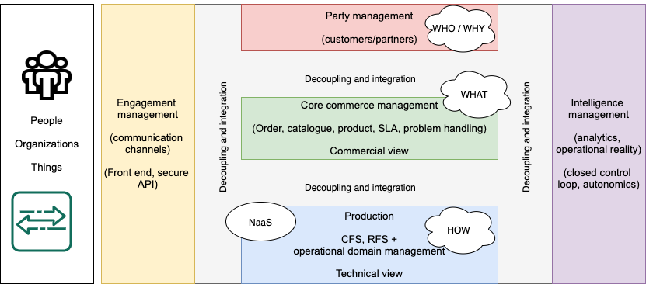
Figure 1.1: The TM Forum ODA functional architecture
In a nutshell:
- The Engagement Management functional block focuses on engagement with end-users (people and systems) that can interact via multiple channels.
- The Party Management functional block handles the processes related to all parties that interact with the organisation, and defines their roles and relationships.
- The Intelligence Management functional block covers the implementation of data analytics processes, and based on the analysis, provides closed control loops for full automation wherever possible.
- The Core Commerce Management functional block focuses on the placement of products and services to the customers, along with product lifecycle management.
- The Production functional block manages the delivery and lifecycle of all customer-facing and resource-facing services that can be based on different technologies or might be a combination of multiple operational domains, including multi-domain services provided with the cooperation of other parties.

Architecture Analysis

High-Level OAV Approach
Main principles and drivers for the NREN architecture… high-level goals, vision, strategy…

Mapping to ODA Functional Architecture
Put into context of the TM Forum ODA functional representation, the NREN Network Management System (NMS) architecture components can be represented as in Figure 2.1. The white boxes in the diagram represent NREN network management system architecture components, and their placement within the ODA functional blocks is defined based on their main functionalities. If the components provide complex multifaceted functionalities, they are broken down into sub-components which are placed in the respective functional block (e.g. membership database).
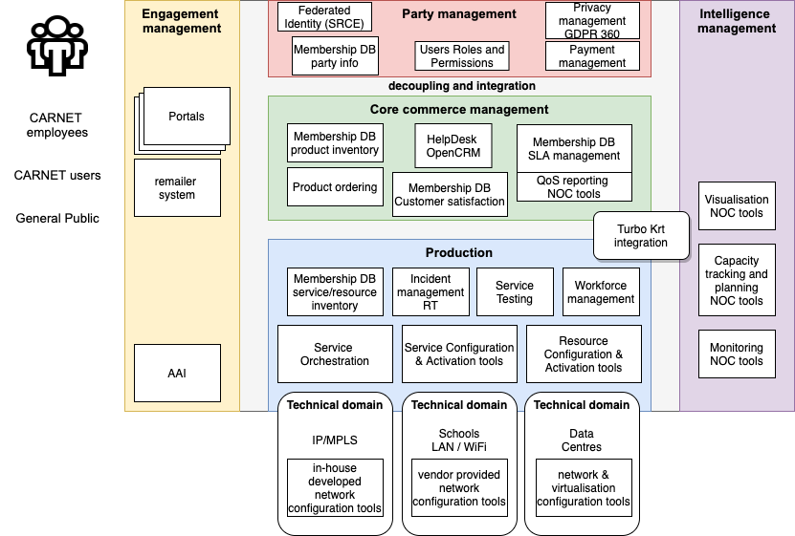
Figure 2.1: Example mapping: CARNET NMS components mapped to the TM Forum ODA

Engagement Management
Brief introduction to the components mapped in this functional block...

Party Management
Brief introduction to the components mapped in this functional block...

Core Commerce Management
Brief introduction to the components mapped in this functional block...

Production
Brief introduction to the components mapped in this functional block...

Technical Domains
Any specific technical domains go here with a short description of each…
- Technical domain 1 – this technical domain is…
- Technical domain 1 – ...

Intelligence Management
Description of components mapped in this functional block…

Conclusions
Overall conclusion, what are the main components and strong points of this approach...

Glossary
BSS Business Support System
NMS Network Management System
NREN National Research and Education Network
OAV Orchestration, Automation and Virtualisation
ODA Open Digital Architecture
OSS Operational Support System

References

[] Example reference [See Adding References for help]
[] TM Forum, Open Digital Architecture (ODA): https://www.tmforum.org/oda/
[] GN4-3 D6.6 Transforming Services with Orchestration and Automation: https://resources.geant.org/wp-content/uploads/2022/02/D6.6-Transforming_Services_with_Orchestration_and_Automation.pdf

